Fig 1 In supervisor remarks case not found
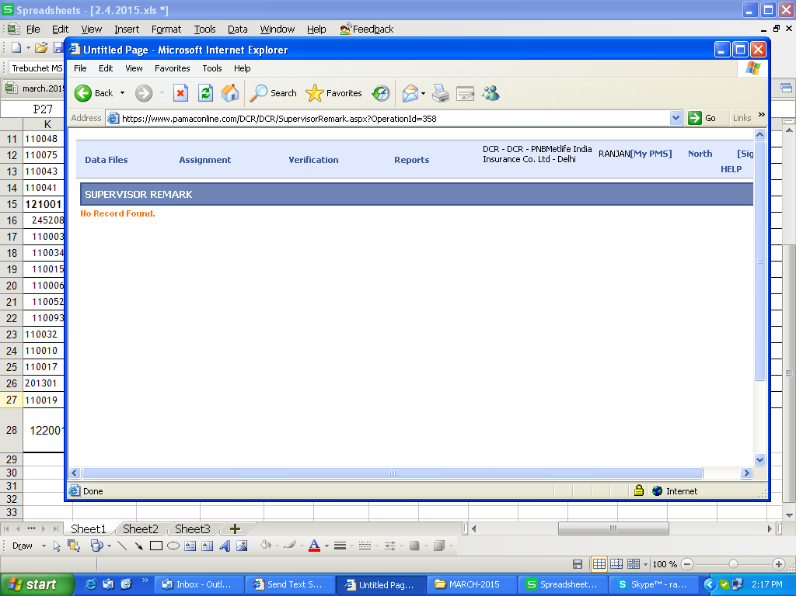

Fig 2 in status updation case not found of L&T
